Electric Cars

Student’s Name
Department, University
Course Number and Name
Instructor’s Name
Date
Electric Cars
The idea of developing electric cars is to ensure fuel-efficient production and lower the emission of wastes. Electric cars ensure fuel is efficiently used by vehicles to prevent pollution of the environment. Electric cars do not pollute the environment because of their efficiency to conserve the electricity used in their performance. Zero-emission is the ultimate goal of electric cars to assist promotes the conservation of the surrounding (Desai Et al., 2019). Society would achieve an environment that is free from pollutions generated by fuel cars. Overreliance on gasoline cars has affected operations of the atmosphere by damaging the ozone layer. Limiting the emission of greenhouse gases is the main goal electric cars promote.
The creation of electric cars is useful to eliminate the pollution of air that is common in developed and developing countries. Conserving the environment is the main aim of electric cars to produce emissions in the air. Vehicles using fuels promote massive emissions that affect the air quality that people require for their living conditions. Addressing the problem of gases emission in the surrounding is significant in promoting safety on the health of citizens. Fuels and gases emitted in the environment cause acid rain, cancer, and stunted plant growth. Developments in society remain stunted because of the emissions from fuel vehicles. Thus, the production of electric cars is integral in making a zero-tolerant environment of emissions.
The futuristic design of modern vehicles has made Tesla achieve a sustainable competitive advantage. Most people purchase vehicles to help prevent pollution of the environment. Tesla's success has been made crucial through proper leadership and designing of modern electric vehicles. Productive leadership in the Tesla Company has led to creating changes that ensure the surrounding is conserved for future generations to live appropriately. Sustainable conservation of the environment has built the brand of electric cars in developed countries.
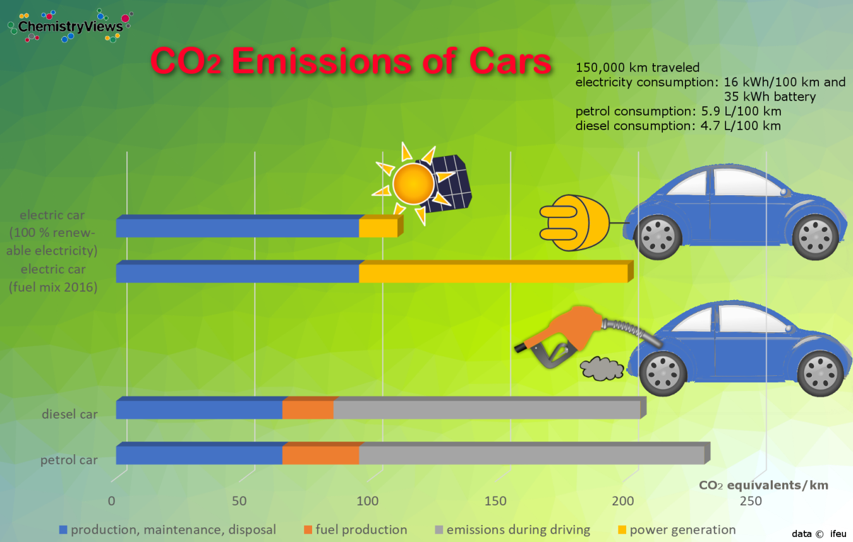
Electric cars emit low Carbon monoxide than diesel and petrol cars. The electric cars control the amount of carbon monoxide that is emitted to the surrounding (Desai Et al., 2019). Diesel and petrol cars consume much oil that are burned and emitted to produce large amounts of carbon monoxide. Carbon monoxide pollutes the air that organisms use.
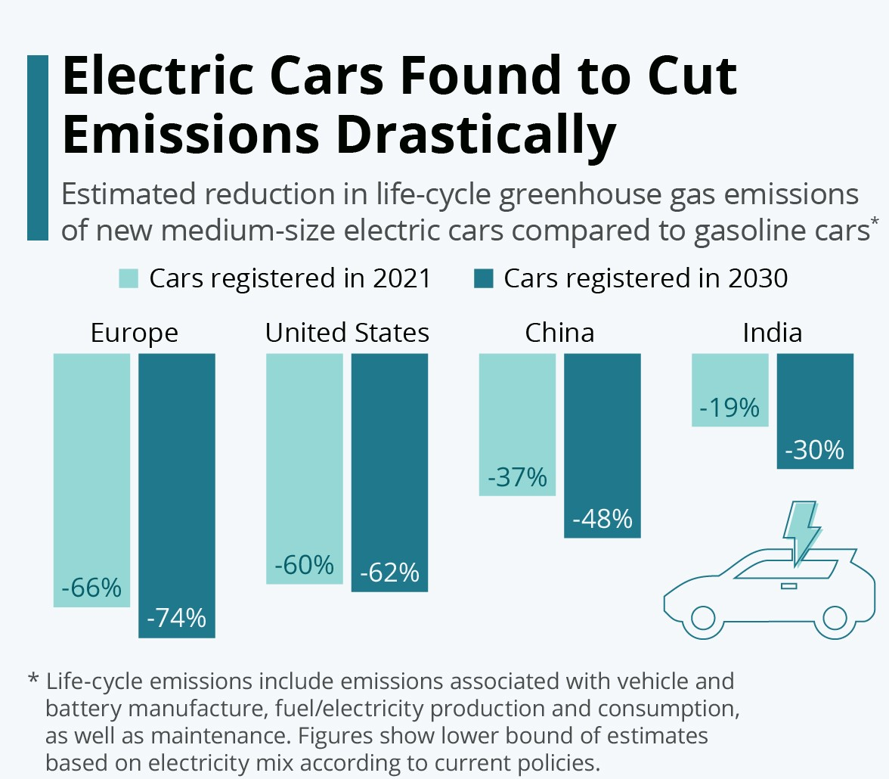
Electric cars have reduced the emission of greenhouse gases drastically compared to gasoline cars in different countries. The consumption of gasoline cars is high that leads to increased pollution of the environment (He Et al., 2019). Many electric have been bought by most people compared to gasoline cars in the developed countries. Limiting the amount of greenhouses emitted to the environment is essential in reducing pollutants emission.
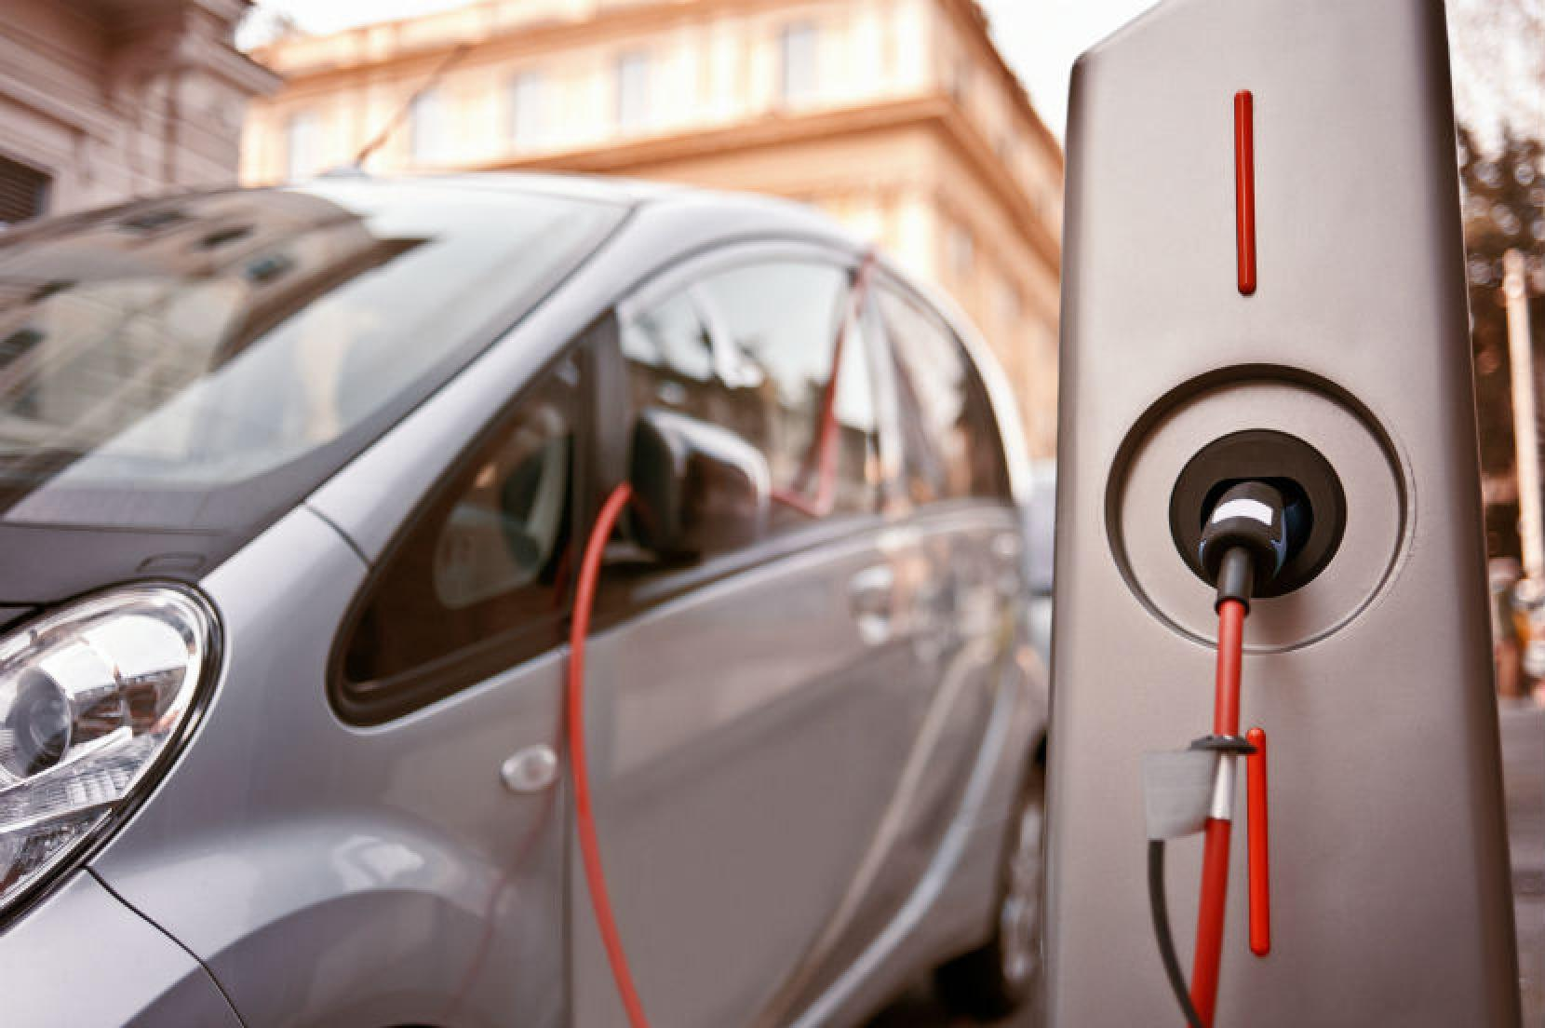
The charging system for electric cars is efficient in allowing maximum charge to be undertaken for eight hours. There are no smells of fuel that may cause problem on people working around the charging points. Vehicles have got designated charging stations that are adequate. Affordable charging would improve the condition of the electric vehicles that most people have purchased in the recent times.
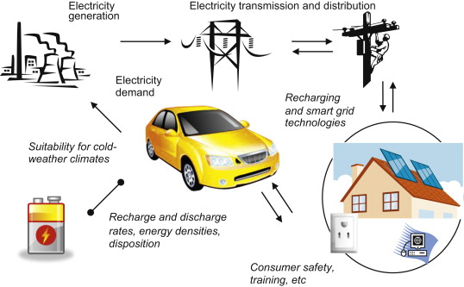
Electricity generation provides the best source of energy to be used by electric cars. People can install charging spots to ensure the reliance of electric charging to be enhanced. Electricity demand by electric vehicles is effective in creation of productive management of pollution of air. Much electricity generated can assist in ensuring electric cars are managed properly to reduce pollution.
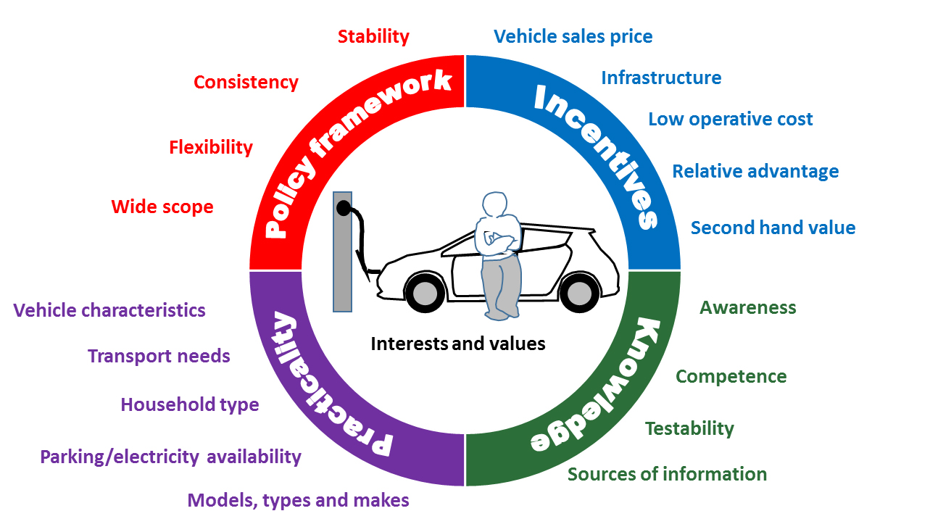
Electric cars have a wide scope of maintaining stability, consistency, and competence of using electricity. Management of policy frameworks for conserving the environment is the main agenda that electric cars are built to achieve. Conservation has been developed to improve practicality and incentives of achieving the values and interests of development. Vehicles should use household electricity to maintain their efficiency when driving to different places.

References
Desai, R. R., Chen, R. B., Hittinger, E., & Williams, E. (2019). Heterogeneity in economic and carbon benefits of electric technology vehicles in the US. Environmental science & technology, 54(2), 1136-1146.
He, X., Zhang, S., Wu, Y., Wallington, T. J., Lu, X., Tamor, M. A., ... & Hao, J. (2019). Economic and climate benefits of electric vehicles in China, the United States, and Germany. Environmental science & technology, 53(18), 11013-11022.

